VISTA PhD Days 2024 – Research based innovation

Pre-read for participating PhDs

The Vista PhD Days in February will address research and researcher-driven innovation. We have several examples that fundamental research may also contribute to innovation in industry, public section and even the research itself. There exist some definitions of what we mean with innovation. It can be methods, technology and services that represent something new, it should be useful and taken in use. We will during these two days address various steps in innovation from generation of ideas and commercialization.

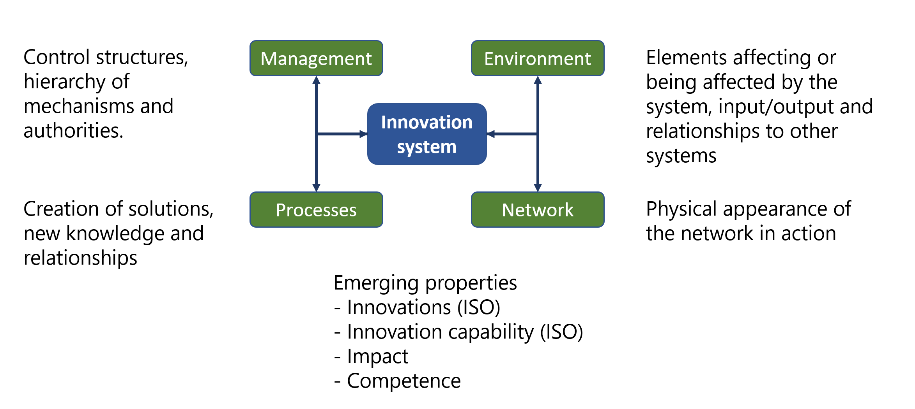
Figure: An innovation system model (Source: Skjølsvik, Kaloudis, 2023. Innovating the Innovation System Thinking: a systemism Model. Journal of the Knowledge Economy.)

The innovation system: Innovation is a wide, vague and for many an unclear concept. Innovation is always a team effort, influenced by many factors, associated with risk but also reward and a prerequisite for change. In the workshop you will be introduced to the key ontology and semantics related to innovation and innovation systems. A innovation system based on system theory is presented in the figure above, and for a high-level introduction to the innovation system the scientific article is available for workshop pre-read: https://link.springer.com/content/pdf/10.1007/s13132-023-01561-w.pdf.
The innovation process: All new knowledge has value for someone. For research-based innovation, the knowledge emerges from the different research activities (basic, applied). A PhD research plan typically describes this in different steps such as insight and problem definition, discovery and solution formulation and theoretical and/or experimental validation. At the end of the research a functional solution prototype is ready for further development, refinement and market introduction. A topic in the workshop will be the possible pathways from research to impact for the society, the stakeholders involved and examples of such pathways.
Innovation and impact on the environment: When new knowledge is found useful and taken into use innovation takes place. When the innovation is adopted by many the accumulated effect represents the impact in one or more dimensions (e.g. expressed by contributions to the UN susyainability goals). Through the mandatory pre-work and during the workshop the relationships between research, value and impact will be a key topic.
Key management aspects: Property is a term that intuitively connect with value. The workshop will introduce you to why the management of intellectual property is important and how this may be done for your work.

Mandatory Pre-work: Each participant prepares a two-minute verbal presentation about their PhD research. This will be used during the workshop.
To prepare, imagine that you meet an inquisitive relative to whom you need to explain what your research is all about. This relative has no prior knowledge about your field, is unlikely to understand theoretical concepts, and gets bored easily. How will you explain your research to this person before they lose interest?
Some guiding questions that you can use:
- What is or could be the new knowledge you develop in your research?
- What are or could be the key results in your research?
- Who could these results be valuable for?
- How could these results be used?
- What could your role be in realizing the value of your research results?
Time recommended for the pre-work: Not more than 30 minutes.

